2024
용의 해
甲辰年
KAUPA Calendar

Designed by Young B. Choi © 2024
For Dedicated KAUPA Members and Families with LOVE

January
2024
Korean American University Professors Association
“Time is the only critic without ambition.” ― John Steinbeck | 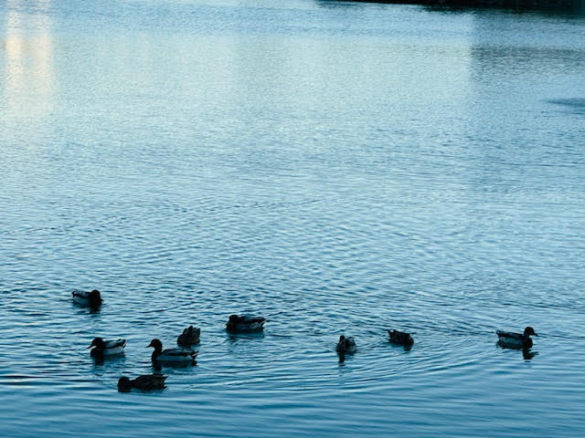
Sunday | Monday | Tuesday | Wednesday | Thursday | Friday | Saturday
 | 1 | 2 | 3 | 4 | 5 | 6
 | New Year’s Day
7 | 8 | 9 | 10 | 11 | 12 | 13
14 | 15 | 16 | 17 | 18 | 19 | 20
KAUPA Letters Article Submission Due | MLK, Jr. Birthday
21 | 22 | 23 | 24 | 25 | 26 | 27
28 | 29 | 30 | 31
February
2024
Korean American University Professors Association
“All great and precious things are lonely.” ― John Steinbeck, East of Eden

Sunday | Monday | Tuesday | Wednesday | Thursday | Friday | Saturday
 |  |  |  | 1 | 2 | 3
 |  |  |  | KAUPA Letters Publication
4 | 5 | 6 | 7 | 8 | 9 | 10
11 | 12 | 13 | 14 | 15 | 16 | 17
 |  |  | Ash Wednesday
18 | 19 | 20 | 21 | 22 | 23 | 24
 | Presidents Day
25 | 26 | 27 | 28 | 29
March
2024
Korean American University Professors Association
“There’s more beauty in truth, even if it is dreadful beauty.”  ― John Steinbeck, East of Eden | 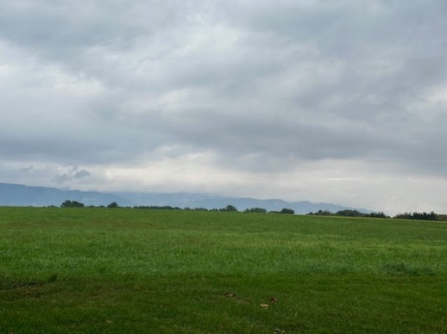
Sunday | Monday | Tuesday | Wednesday | Thursday | Friday | Saturday
 |  |  |  |  | 1 | 2
3 | 4 | 5 | 6 | 7 | 8 | 9
10 | 11 | 12 | 13 | 14 | 15 | 16
 |  |  |  |  | KAUPA Letters Article Submission Due
17 | 18 | 19 | 20 | 21 | 22 | 23
24 | 25 | 26 | 27 | 28 | 29  Good Friday | 30
31
Easter Sunday
April
2024
Korean American University Professors Association
“And now that you don’t have to be perfect, you can be good.” ― John Steinbeck, East of Eden | 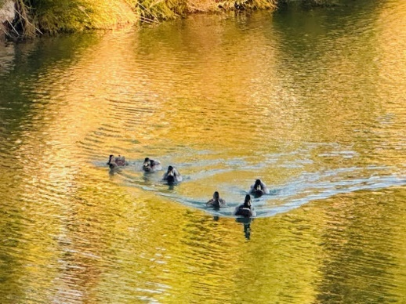
Sunday | Monday | Tuesday | Wednesday | Thursday | Friday | Saturday
 | 1 | 2 | 3 | 4 | 5 | 6
 | KAUPA Letters Publication
7 | 8 | 9 | 10 | 11 | 12 | 13
14 | 15 | 16 | 17 | 18 | 19 | 20
21 | 22 | 23 | 24 | 25 | 26 | 27
28 | 29 | 30
May
2024
Korean American University Professors Association
“When two people meet, each one is changed by the other, so you’ve got two new people.”  ― John Steinbeck | 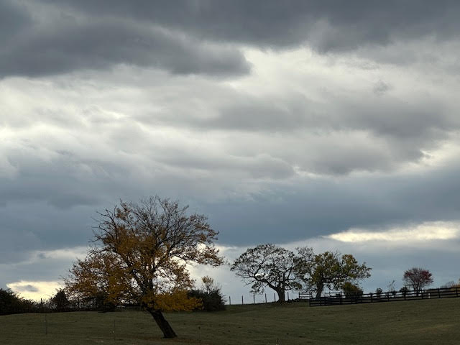
Sunday | Monday | Tuesday | Wednesday | Thursday | Friday | Saturday
 |  |  | 1 | 2 | 3 | 4
5 | 6 | 7 | 8 | 9 | 10 | 11
12 | 13 | 14 | 15 | 16 | 17 | 18
 |  |  | KAUPA Letters Article Submission Due
19 | 20 | 21 | 22 | 23 | 24 | 25
26 | 27 | 28 | 29 | 30 | 31
 | Memorial Day
June
2024
Korean American University Professors Association
“Don’t worry about losing. If it is right, it happens – The main thing is not to hurry. Nothing good gets away.”  ― John Steinbeck | 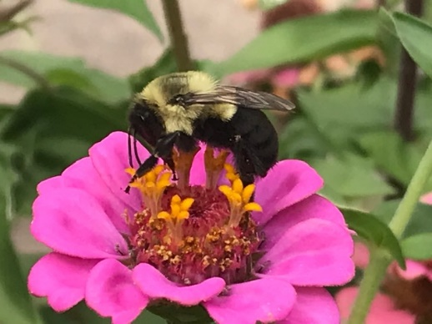
Sunday | Monday | Tuesday | Wednesday | Thursday | Friday | Saturday
 |  |  |  |  |  | 1
 |  |  |  |  |  | KAUPA Letters Publication
2 | 3 | 4 | 5 | 6 | 7 | 8
9 | 10 | 11 | 12 | 13 | 14 | 15
16 | 17 | 18 | 19 | 20 | 21 | 22
 |  |  | Juneteenth national Independence Day
23 | 24 | 25 | 26 | 27 | 28 | 29
30
July
2024
Korean American University Professors Association
The free exploring mind of the individual human is the most valuable thing in the world.”  ― John Steinbeck, East of Eden | 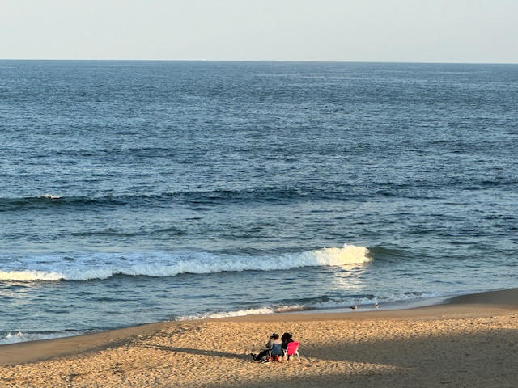
Sunday | Monday | Tuesday | Wednesday | Thursday | Friday | Saturday
 | 1 | 2 | 3 | 4 | 5 | 6
 |  |  |  | Independence Day
7 | 8 | 9 | 10 | 11 | 12 | 13
14 | 15 | 16 | 17 | 18 | 19 | 20
 | KAUPA Letters Article Submission Due
21 | 22 | 23 | 24 | 25 | 26 | 27
28 | 29 | 30 | 31
August
2024
Korean American University Professors Association
What good is the warmth of summer, without the cold of winter to give it sweetness.”  ― John Steinbeck, Travels with Charley: In Search of America | 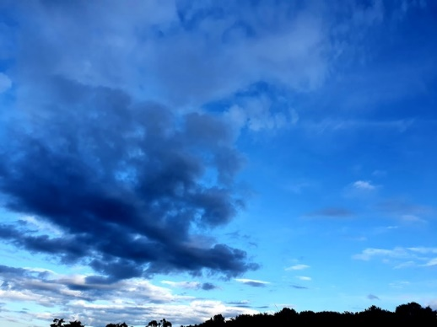
Sunday | Monday | Tuesday | Wednesday | Thursday | Friday | Saturday
 |  |  |  | 1 | 2 | 3
 |  |  |  | KAUPA Letters Publication
4 | 5 | 6 | 7 | 8 | 9 | 10
11 | 12 | 13 | 14 | 15 | 16 | 17
18 | 19 | 20 | 21 | 22 | 23 | 24
25 | 26 | 27 | 28 | 29 | 30 | 31
September
2024
Korean American University Professors Association
I believe a strong woman may be stronger than a man, particularly if she happens to have love in her heart. I guess a loving woman is indestructible.”  ― John Steinbeck | 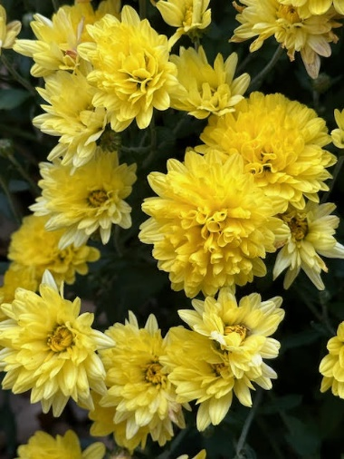
Sunday | Monday | Tuesday | Wednesday | Thursday | Friday | Saturday
1 | 2  Labor Day | 3 | 4 | 5 | 6 | 7
8 | 9 | 10 | 11 | 12 | 13 | 14
15 | 16 | 17 | 18 | 19 | 20 | 21
KAUPA Letters Article Submission Due
22 | 23 | 24 | 25 | 26 | 27 | 28
29 | 30
October
2024
Korean American University Professors Association
“Try to understand men, if you understand each other, you will be kind to each other. Knowing a man well never leads to hate and nearly always leads to love.”  ― John Steinbeck, Of Mice and Men | 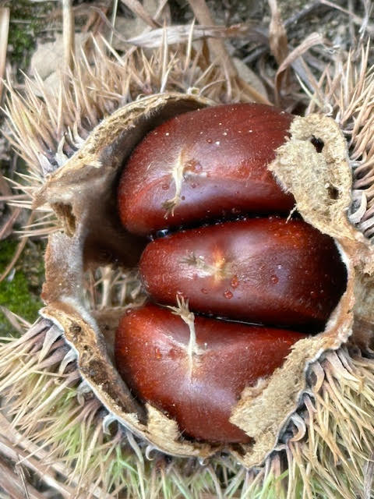
Sunday | Monday | Tuesday | Wednesday | Thursday | Friday | Saturday
 |  | 1 | 2 | 3 | 4 | 5
 |  | KAUPA Letters Publication
6 | 7 | 8 | 9 | 10 | 11 | 12
 |  |  |  |  |  | KAUPA Day
13 | 14 | 15 | 16 | 17 | 18 | 19
 | Columbus Day
20 | 21 | 22 | 23 | 24 | 25 | 26
27 | 28 | 29 | 30 | 31
November
2024
Korean American University Professors Association
“You can only understand people if you feel them in yourself.”  ― John Steinbeck | 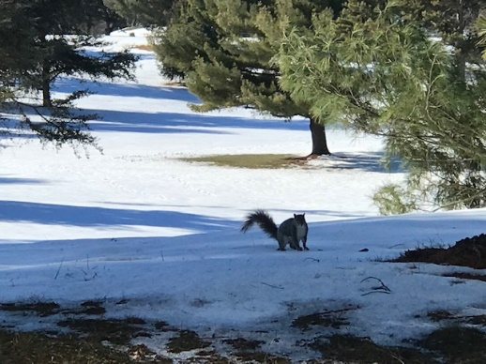
Sunday | Monday | Tuesday | Wednesday | Thursday | Friday | Saturday
 |  |  |  |  | 1 | 2
3 | 4 | 5 | 6 | 7 | 8 | 9
 |  |  |  | Election Day
10 | 11 | 12 | 13 | 14 | 15 | 16
 | Veterans Day |  |  |  | KAUPA Letters Article Submission Due
17 | 18 | 19 | 20 | 21 | 22 | 23
24 | 25 | 26 | 27 | 28 | 29 | 30
Thanksgiving
Day

December
2024
Korean American University Professors Association
“The weight of knowledge is too great for one mind to absorb.”  ― John Steinbeck, East of Eden | 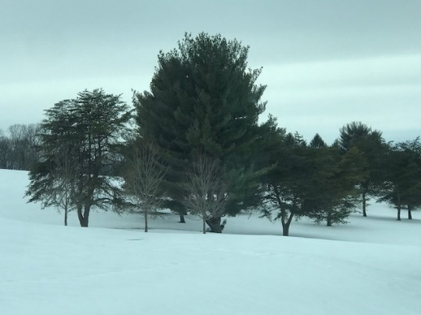
Sunday | Monday | Tuesday | Wednesday | Thursday | Friday | Saturday
1 | 2 | 3 | 4 | 5 | 6 | 7
KAUPA Letters Publication
8 | 9 | 10 | 11 | 12 | 13 | 14
15 | 16 | 17 | 18 | 19 | 20 | 21
 |  |  |  |  | KAUPA Year End Social
22 | 23 | 24 | 25 | 26 | 27 | 28
 |  |  | Christmas Day
29 | 30 | 31

