2022
호랑이의 해
壬寅年
KAUPA Calendar

Designed by Young B. Choi © 2022
For Dedicated KAUPA Members and Families with LOVE

January
2022
Korean American University Professors Association
Quote of the Month

The only way to begin is to stop talking and start doing.
- Walter Elias Disney -

Sunday | Monday | Tuesday | Wednesday | Thursday | Friday | Saturday
 |  |  |  |  |  | 1
 |  |  |  |  |  | 新正/NYD
2 | 3 | 4 | 5 | 6 | 7 | 8
 | (12/1 Lunar) |  | 小寒
9 | 10 | 11 | 12 | 13 | 14 | 15
 |  |  |  |  | KAUPA Letters Article Submission Due
16 | 17 | 18 | 19 | 20 | 21 | 22
 | MLK Jr. Day |  |  | 大寒
23 | 24 | 25 | 26 | 27 | 28 | 29
30 | 31
February
2022
Korean American University Professors Association
Quote of the Month  Rhythm and harmony find their way into the inward places of the soul.  - Plato - | 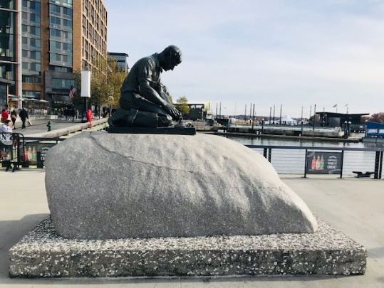
Sunday | Monday | Tuesday | Wednesday | Thursday | Friday | Saturday
 |  | 1 | 2 | 3 | 4 | 5
 |  | KAUPA Letters Publication  설날(舊正) |  |  | 立春
6 | 7 | 8 | 9 | 10 | 11 | 12
13 | 14 | 15 | 16 | 17 | 18 | 19
Valentine’s Day |  | 正月대보름 |  |  |  | 雨水
20 | 21 | 22 | 23 | 24 | 25 | 26
 | President’s Day
27 | 28
March
2022
Korean American University Professors Association
Quote of the Month  Learn from yesterday, live for today, and hope for tomorrow.  - Albert Einstein - | 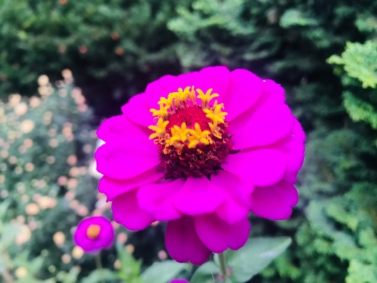
Sunday | Monday | Tuesday | Wednesday | Thursday | Friday | Saturday
 |  | 1 | 2 | 3 | 4 | 5
 |  |  |  | (2/1 Lunar) |  | 驚蟄
6 | 7 | 8 | 9 | 10 | 11 | 12
13 | 14 | 15 | 16 | 17 | 18 | 19
Daylight Saving |  | KAUPA Letters Article Submission Due
20 | 21 | 22 | 23 | 24 | 25 | 26
 | 春分 |  |  | Tenure & Promotion Webinar
27 | 28 | 29 | 30 | 31
April
2022
Korean American University Professors Association
Quote of the Month  Give me a museum and I’ll fill it.  - Pablo Picasso - | 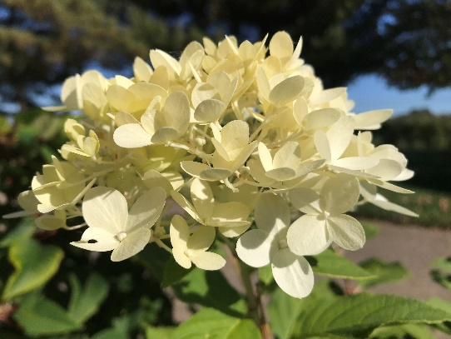
Sunday | Monday | Tuesday | Wednesday | Thursday | Friday | Saturday
 |  |  |  |  | 1 | 2
KAUPA Letters Publication
(3/1 Lunar)
3 | 4 | 5 | 6 | 7 | 8 | 9
 |  | 植木日/淸明 | 寒食
10 | 11 | 12 | 13 | 14 | 15 | 16
17 | 18 | 19 | 20 | 21 | 22 | 23
 |  |  | 穀雨
24 | 25 | 26 | 27 | 28 | 29 | 30
May
2022
Korean American University Professors Association
Quote of the Month  The sun is new each day.  - Heraditus - | 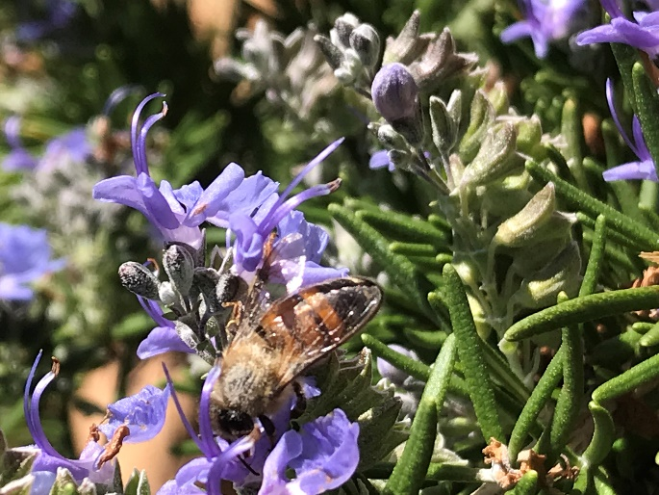
Sunday | Monday | Tuesday | Wednesday | Thursday | Friday | Saturday
1 | 2 | 3 | 4 | 5 | 6 | 7
(4/1 Lunar) |  |  |  | 어린이날  立夏
8 | 9 | 10 | 11 | 12 | 13 | 14
Mother’s D.
부처님오신날
15 | 16 | 17 | 18 | 19 | 20 | 21
스승의 날  KAUPA Letters  Article Submission Due |  |  |  |  |  | 小滿
22 | 23 | 24 | 25 | 26 | 27 | 28
29 | 30 | 31
 | Memorial Day
June
2022
Korean American University Professors Association
Quote of the Month  All good literature rests primarily on insight.  - George H. Lewes - | 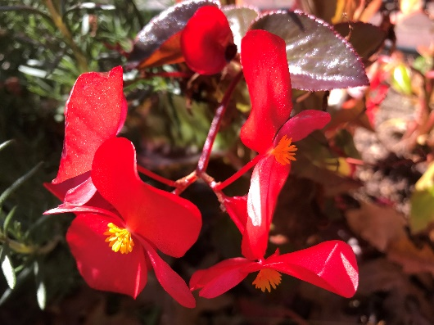
Sunday | Monday | Tuesday | Wednesday | Thursday | Friday | Saturday
 |  |  | 1 | 2 | 3 | 4
 |  |  | KAUPA Letters Publication |  | 端午 (음 5/5)
5 | 6 | 7 | 8 | 9 | 10 | 11
 | 芒種/顯忠日
12 | 13 | 14 | 15 | 16 | 17 | 18
19 | 20 | 21 | 22 | 23 | 24 | 25
Juneteenth  Father’s D. |  | 夏至 |  | Best Teaching Practice Webinar
26 | 27 | 28 | 29 | 30
 |  |  | (6/1 Lunar)
July
2022
Korean American University Professors Association
Quote of the Month  History does not repeat itself. But it does rhyme.  - Mark Twain - | 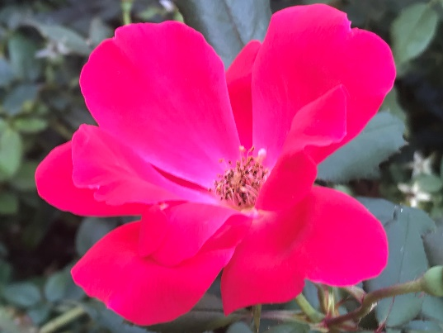
Sunday | Monday | Tuesday | Wednesday | Thursday | Friday | Saturday
 |  |  |  |  | 1 | 3
KAUPA
Scholarship App. Due
3 | 4 | 5 | 6 | 7 | 8 | 9
 | Independence Day |  |  | 小暑
10 | 11 | 12 | 13 | 14 | 15 | 16
 |  |  |  |  | KAUPA Letters Article Submission Due | 初伏
17 | 18 | 19 | 20 | 21 | 22 | 23
制憲節 |  |  |  |  |  | 大暑
24 | 25 | 26 | 27 | 28 | 29 | 30
 |  | 中伏 |  |  | (7/1 Lunar)
31
August
2022
Korean American University Professors Association
Quote of the Month  Hope never abandons you, you abandon it.  - George Weinberg - | 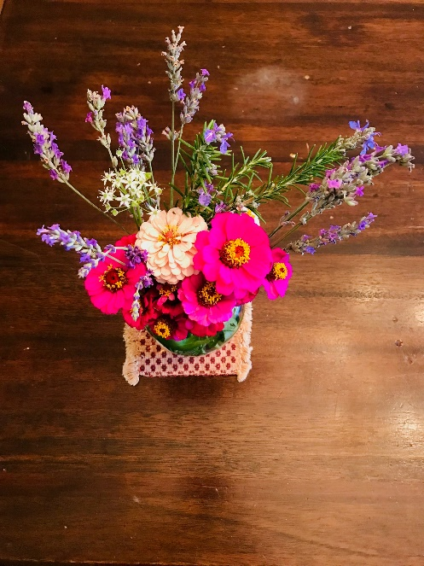
Sunday | Monday | Tuesday | Wednesday | Thursday | Friday | Saturday
 | 1 | 2 | 3 | 4 | 5 | 6
 | KAUPA Letters Publication | KAUPA  International Conference | KAUPA  International Conference | 七夕
7 | 8 | 9 | 10 | 11 | 12 | 13
立秋
14 | 15 | 16 | 17 | 18 | 19 | 20
末伏
光復節
21 | 22 | 23 | 24 | 25 | 26 | 27
 |  | 處暑 |  |  |  | (8/1 Lunar)
28 | 29 | 30 | 31
September
2022
Korean American University Professors Association
Quote of the Month  All of life is a constant education.  - Eleanor Roosevelt - | 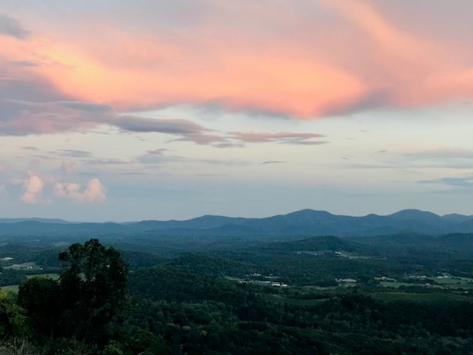
Sunday | Monday | Tuesday | Wednesday | Thursday | Friday | Saturday
 |  |  |  | 1 | 2 | 3
4 | 5 | 6 | 7 | 8 | 9 | 10
 | Labor Day |  |  |  |  | 秋夕(8/15)
11 | 12 | 13 | 14 | 15 | 16 | 17
 |  |  |  | KAUPA Letters Article Submission Due | Best Research Practice Webinar
18 | 19 | 20 | 21 | 22 | 23 | 24
 |  |  |  |  | 秋分
25 | 26 | 27 | 28 | 29 | 30
 | (9/1 Lunar)
October
2022
Korean American University Professors Association
Quote of the Month  My problem is how to find the best way of being useful.  - Jacques Delors - | 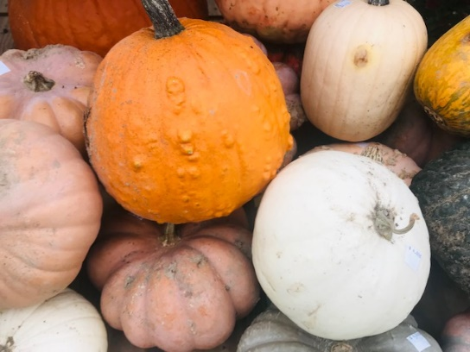
Sunday | Monday | Tuesday | Wednesday | Thursday | Friday | Saturday
 |  |  |  |  |  | 1
 |  |  |  |  |  | KAUPA Letters Publication
2 | 3 | 4 | 5 | 6 | 7 | 8
 | 開天節 |  |  |  |  | 寒露
9 | 10 | 11 | 12 | 13 | 14 | 15
한글날 | Columbus Day |  | KAUPA Day
16 | 17 | 18 | 19 | 20 | 21 | 22
23 | 24 | 25 | 26 | 27 | 28 | 29
霜降 |  | (10/1 Lunar)
30 | 31  Halloween
November
2022
Korean American University Professors Association
Quote of the Month  We tend to look through language and not realize how much power language has.  - Deborah Tannen - | 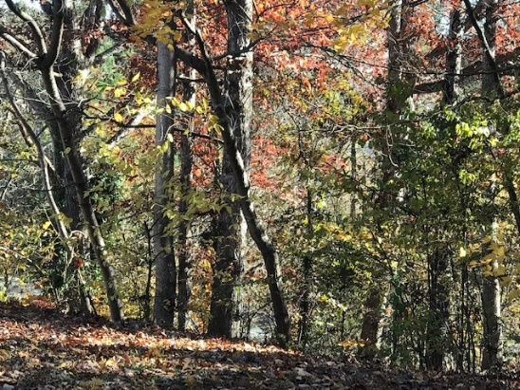
Sunday | Monday | Tuesday | Wednesday | Thursday | Friday | Saturday
 |  | 1 | 2 | 3 | 4 | 5
6 | 7 | 8 | 9 | 10 | 11 | 12
Daylight Saving (End) | 立冬 | Election Day |  |  | Veteran’s Day
13 | 14 | 15 | 16 | 17 | 18 | 19
 |  | KAUPA Letters Article Submission Due
20 | 21 | 22 | 23 | 24 | 25 | 26
 |  | 小雪 |  | Thanksgiving  Day  (11/1 Lunar) | Black Friday
27 | 28 | 29 | 30
 | Cyber Monday
December
2022
Korean American University Professors Association
Quote of the Month  A picture is a model of reality.  - Ludwig Wittgenstein - | 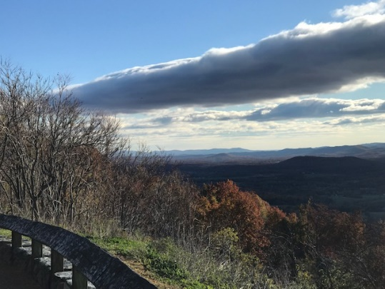
Sunday | Monday | Tuesday | Wednesday | Thursday | Friday | Saturday
 |  |  |  | 1 | 2 | 3
 |  |  |  | KAUPA Letters Publication
4 | 5 | 6 | 7 | 8 | 9 | 10
 |  |  | 大雪
11 | 12 | 13 | 14 | 15 | 16 | 17
 |  |  | KAUPA Year End Social
18 | 19 | 20 | 21 | 22 | 23 | 24
 |  |  |  | 冬至 | (21/1 Lunar) | Christmas Eve
25 | 6 | 7 | 8 | 29 | 30 | 31
Christmas Day
